ASSIGNMENT 1

Name | : Aryan Singh Tomar
Roll No. | : 3314
Class | : TE COMP A

Topic
Fundamental Concepts of Cloud Computing, Cloud Architecture and Deployment Models

1. What is Cloud Computing?
Cloud Computing is the delivery of computing services — servers, storage, databases, networking, software, and analytics — over the Internet ("the cloud") instead of owning and maintaining physical hardware. Instead of buying a computer or server and installing everything yourself, you simply "rent" computing power and storage from a provider and pay only for what you use, exactly like paying an electricity bill for the units you consume.
Real-Life Example: When you save photos on Google Photos or watch a movie on Netflix, you are not storing anything on your own phone's memory permanently — the data lives on Google's or Netflix's servers somewhere in the world, and you simply access it through the Internet. That is cloud computing in action.

Essential Characteristics of Cloud Computing (as defined by NIST):
- On-Demand Self-Service: The user can automatically provision computing resources (servers, storage) without needing human interaction with the provider.
- Broad Network Access: Services are available over the Internet and can be accessed through standard devices — laptops, tablets, smartphones.
- Resource Pooling: Multiple users (tenants) share the same physical resources, which are dynamically assigned as per demand.
- Rapid Elasticity: Resources can be scaled up or down instantly based on workload — e.g., more servers during a sale, fewer at night.
- Measured Service: Resource usage is monitored, controlled, and billed transparently, similar to a utility (water/electricity) bill.

2. Cloud Computing Architecture
Cloud architecture refers to the components and sub-components that together make cloud computing possible. Broadly, it is divided into two ends that communicate with each other over the Internet:
- Front End: This is the side visible to the user — the interface through which a person interacts with the cloud, such as a web browser (Chrome), a mobile app (Instagram app), or a thin client.
- Back End: This is the cloud itself — made up of servers, storage, databases, virtual machines, and the security/management infrastructure that the provider maintains, all hidden from the user.
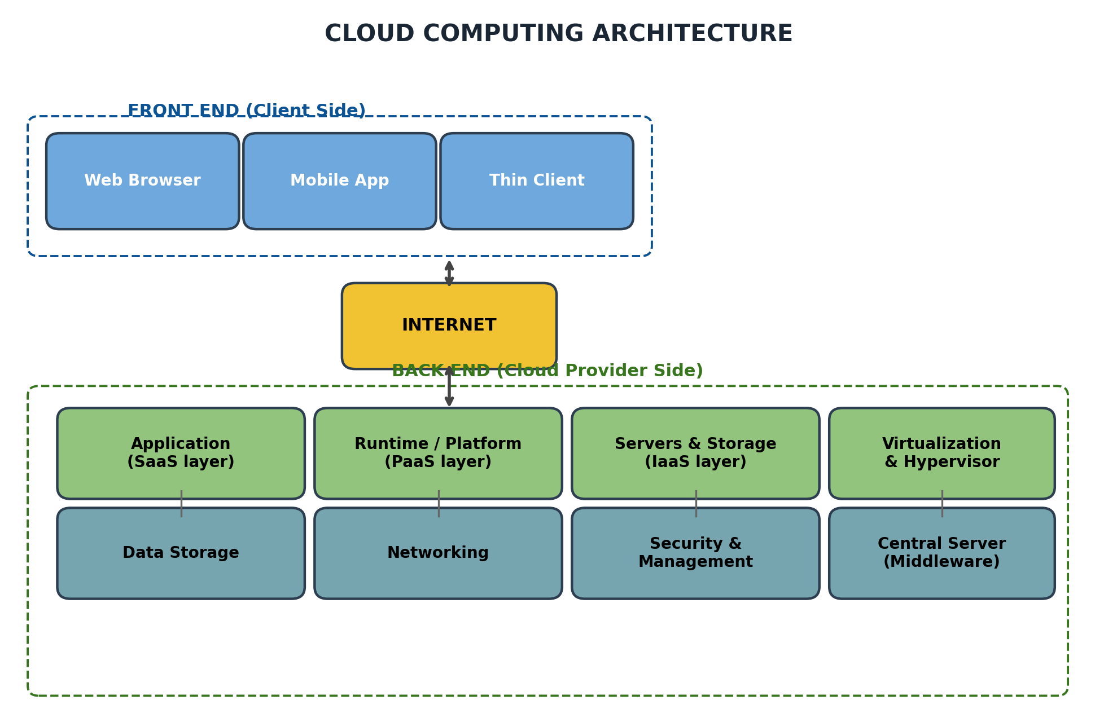
Fig 2.1 — Front End and Back End components of Cloud Architecture
Key components inside the Back End:
Component | Function
Application | The actual software/service the user runs (e.g. Gmail, an e-commerce site).
Service (SaaS/PaaS/IaaS) | The type of cloud service being delivered to the user.
Runtime Cloud | Provides the execution/runtime environment (containers, VMs) for applications.
Storage | Provides scalable space to store user and application data.
Infrastructure | Physical hardware — servers, networking equipment, data centres.
Management | Software that coordinates resource allocation, load balancing, monitoring.
Security | Firewalls, identity/access management, and encryption protecting data.
Real-Life Example: In a food-delivery app like Zomato: the Application is the Zomato app itself, the Runtime Cloud runs its backend code, the Storage holds restaurant menus and order history, and the Security layer protects your saved card details.

3. Virtualization — The Enabling Technology
Virtualization is the technology that makes cloud computing possible. It allows a single physical server to be divided into multiple independent Virtual Machines (VMs), each behaving like a separate computer with its own operating system, memory and storage — even though they all share the same physical hardware underneath. A software layer called the Hypervisor manages and allocates the physical resources (CPU, RAM, disk) among these virtual machines.
- Why It Matters: Instead of buying one physical server per application, a provider can run dozens of virtual servers on a single physical machine, drastically cutting cost and space.
- Hypervisor: Software layer that creates and manages virtual machines. Two types exist — Type 1 (runs directly on hardware, e.g. VMware ESXi) and Type 2 (runs on top of an OS, e.g. Oracle VirtualBox).
Real-Life Example: A single powerful physical server in a Google data centre may simultaneously run separate virtual machines for hundreds of different customers — each customer feels like they have their own private computer, without knowing they are sharing the same physical hardware.

4. Cloud Service Models
Cloud computing services are offered in three main models, differing in how much the provider manages versus how much the user manages. It is best understood as a pyramid — the lower the layer, the more control (and responsibility) the user has; the higher the layer, the more convenience with less control.
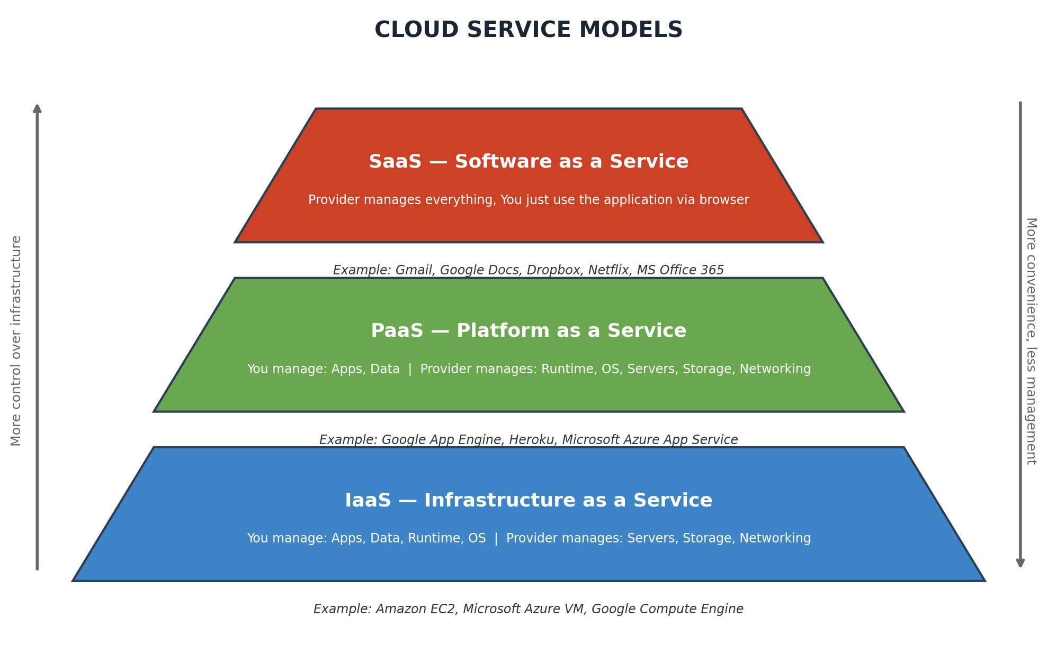
Fig 3.1 — IaaS, PaaS and SaaS compared as layers of increasing convenience
Model | What You Manage | What Provider Manages | Real-Life Example
IaaS (Infrastructure as a Service) | OS, applications, data, runtime | Physical servers, storage, networking, virtualization | Amazon EC2, Microsoft Azure VMs — renting a virtual computer
PaaS (Platform as a Service) | Application code & data only | OS, runtime, servers, storage | Google App Engine, Heroku — upload your code, platform runs it
SaaS (Software as a Service) | Nothing — only use the app | Everything (app + infra) | Gmail, Google Docs, Netflix, MS Office 365

Real-Life Example: Think of it like ordering food: IaaS is buying raw ingredients and cooking yourself in your own kitchen (you manage a lot); PaaS is like a cloud kitchen that gives you a ready kitchen setup and you just cook your dish; SaaS is ordering a fully cooked meal from Zomato — you just consume it, no cooking involved.

5. Cloud Deployment Models
A deployment model defines where the cloud infrastructure is located and who has access to it. There are four major deployment models:
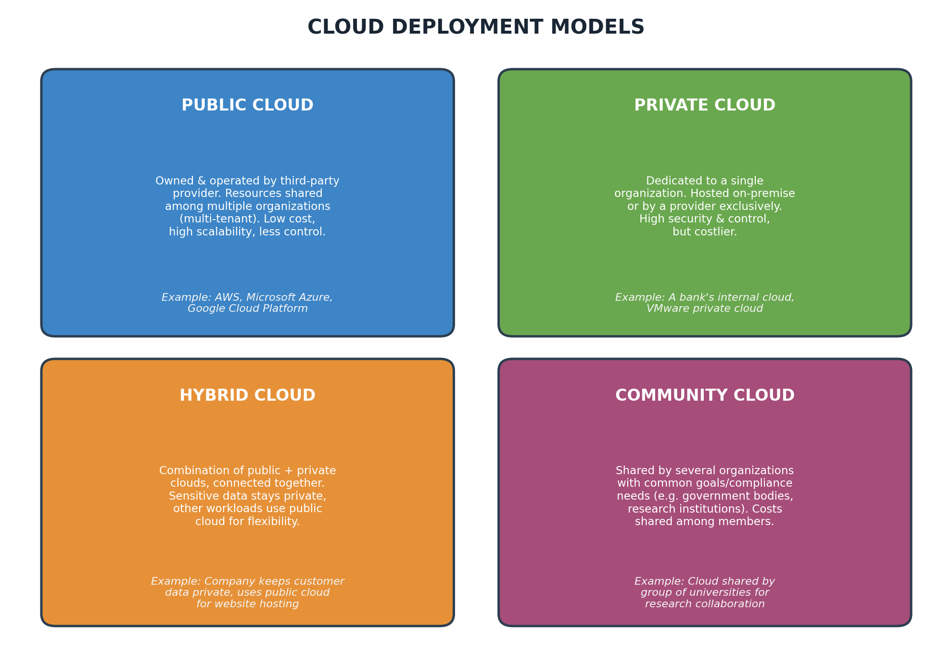
Fig 4.1 — Public, Private, Hybrid and Community Cloud deployment models
Model | Description | Example
Public Cloud | Owned by a third-party provider and shared among many organizations over the public Internet. Low cost, highly scalable, but less control over security. | AWS, Microsoft Azure, Google Cloud Platform
Private Cloud | Dedicated exclusively to one organization, hosted either on their own premises or by a provider. Offers maximum control and security, but is expensive. | A bank's internal cloud for customer transaction data
Hybrid Cloud | A mix of public and private clouds, connected so data/applications can move between them. Sensitive data stays private; other tasks use public cloud. | A company stores confidential HR data privately but hosts its public website on a public cloud
Community Cloud | Shared infrastructure for several organizations having common concerns (security, compliance, jurisdiction), e.g. government or research bodies. | Cloud shared by a group of universities for joint research projects

6. How Cloud Computing Works — The Request Flow
Understanding the step-by-step flow of a cloud request helps in visualising how all the architecture components come together in real time. Consider a simple example — you open Gmail on your phone:
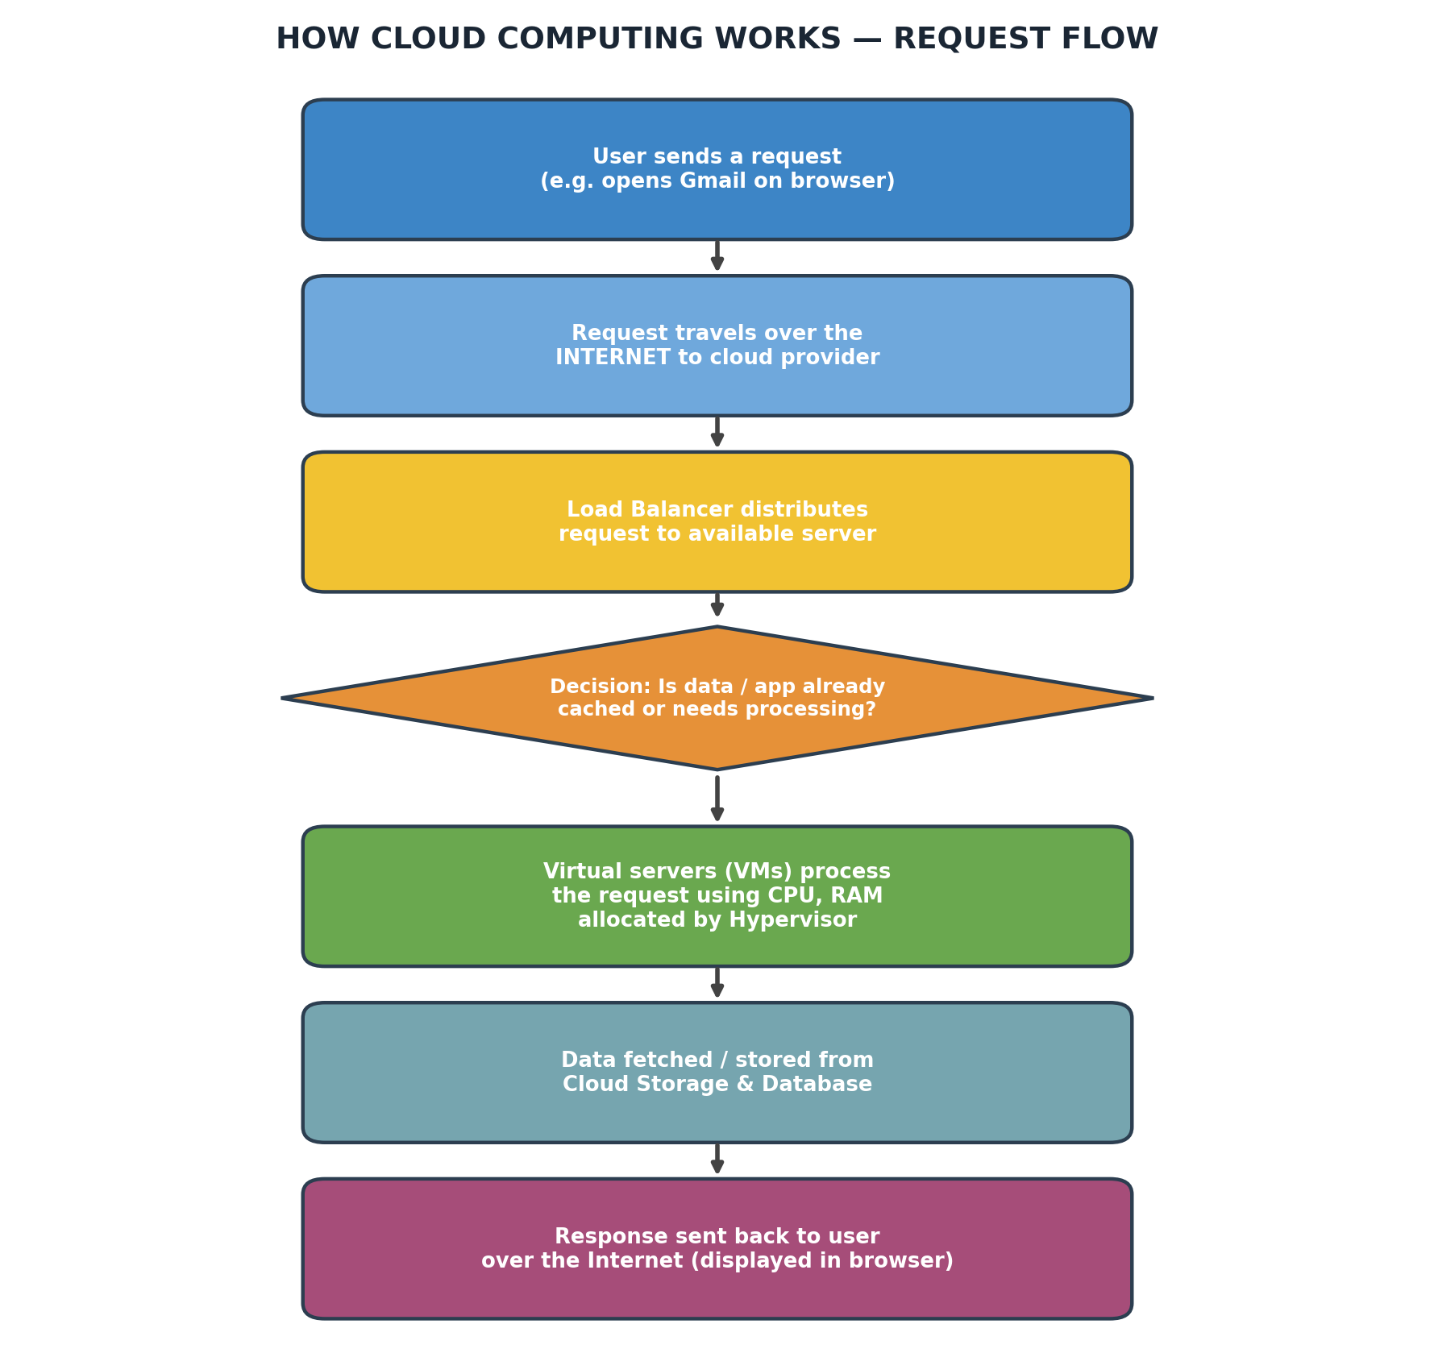
Fig 5.1 — Step-by-step flow of a cloud computing request
- Your phone (front end) sends an HTTP request to open Gmail.
- This request travels through the Internet to Google's data centre.
- A Load Balancer decides which server should handle your request, so no single server is overloaded.
- Virtual servers, powered by a hypervisor, process the request — checking your login, fetching your inbox.
- Your emails are fetched from cloud storage/databases distributed across multiple servers.
- The response (your inbox) travels back over the Internet and is displayed on your screen — all of this happens in a fraction of a second.

7. Advantages & Challenges of Cloud Computing
- Cost Efficiency: Pay only for the resources you actually use, avoiding heavy upfront hardware investment.
- Scalability: Instantly scale resources up during high demand (e.g. Flipkart during a sale) and scale down later.
- Accessibility: Access your data and applications from anywhere, on any device with an Internet connection.
- Disaster Recovery: Providers maintain multiple copies of data across locations, ensuring recovery during failures.
- Automatic Updates: The provider handles hardware maintenance, patching and updates automatically.
Along with these benefits, a few challenges are worth noting for a balanced understanding:
- Data Security & Privacy: Storing sensitive data on third-party servers raises concerns about who can access it.
- Internet Dependency: Cloud services require a stable Internet connection; without it, access is lost.
- Vendor Lock-in: Moving completely from one cloud provider to another can be technically difficult.

8. Conclusion
Cloud computing has transformed the way individuals and organizations use technology — replacing the need for expensive physical infrastructure with flexible, on-demand, pay-as-you-go services accessed over the Internet. Its architecture, built on a clear division between front end and back end, is delivered through three service models (IaaS, PaaS, SaaS) and can be deployed via four models (Public, Private, Hybrid, Community) depending on an organization's needs for cost, control and security. From everyday apps like Gmail and Netflix to enterprise systems run by banks and governments, cloud computing today forms the invisible backbone of the digital world.

Quick Revision — For Viva
Question | One-Line Answer
What is cloud computing? | Delivery of computing services (servers, storage, software) over the Internet on a pay-as-you-use basis.
5 NIST characteristics? | On-demand self-service, broad network access, resource pooling, rapid elasticity, measured service.
Two parts of cloud architecture? | Front End (client/user side) and Back End (servers, storage, provider side).
Three service models? | IaaS (infrastructure), PaaS (platform), SaaS (software) — increasing convenience, decreasing control.
Four deployment models? | Public, Private, Hybrid, Community.
Difference: Public vs Private cloud? | Public is shared & low cost; Private is dedicated to one organization, more secure & costly.
Example of SaaS? | Gmail, Google Docs, Netflix, Office 365.
Example of IaaS? | Amazon EC2, Azure Virtual Machines.

